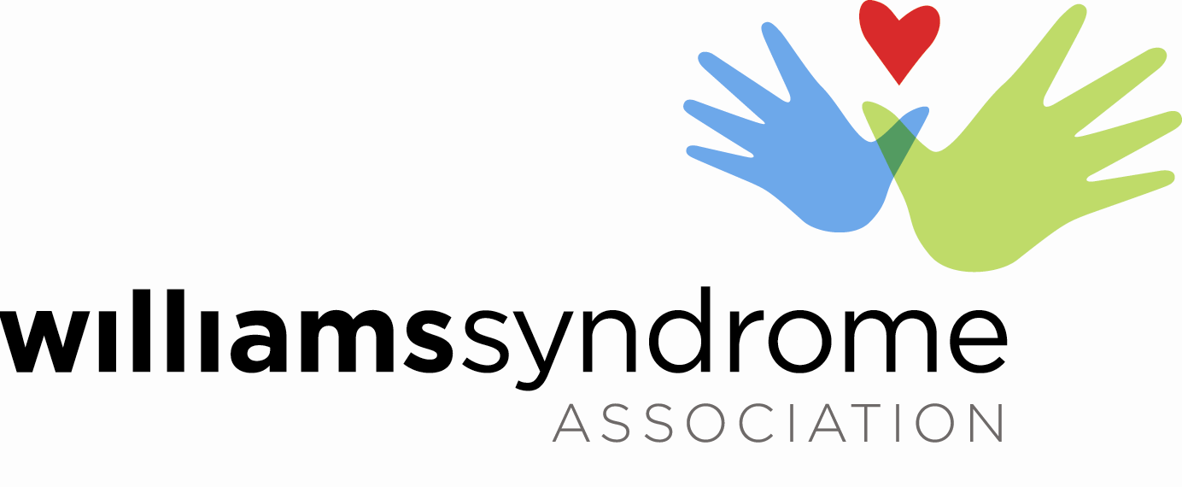
Donor’s Name
Donor’s Address
Donor’s Address

Dear [Donor's Name],
On behalf of the entire Williams syndrome community, we want to express our deepest gratitude for your generous donation of ____________________________ to the Williams Syndrome Association. Your unwavering support means the world to us.

Williams syndrome (WS) is a genetic condition that presents at birth and affects individuals from diverse backgrounds. It is characterized by a range of medical challenges, including cardiovascular disease, developmental delays, and learning disabilities. With 1 in 10,000 people worldwide, an estimated 30,000 individuals in the United States alone are impacted by this condition.

The Williams Syndrome Association (WSA) serves as the primary and most comprehensive resource for individuals and families living with Williams syndrome, as well as for doctors, researchers, and educators. Each day, we strive to make a positive difference in the lives of those affected by Williams syndrome.

As we look ahead to the future, we have set ambitious goals for the coming years, and your support of the association plays a crucial role in achieving them. In the upcoming year, the WSA will actively engage with over 5,000 member families, prepare for our highly anticipated national convention, provide vital scholarship assistance to families in need, advance research efforts in Williams syndrome, expand our initiatives during WS Awareness Month, introduce new and impactful camp programs, foster regional collaborations, strengthen our adult programming, and embark on various other important endeavors. Your unwavering commitment to this cause makes all these initiatives possible.

We want to emphasize that the Williams Syndrome Association is dedicated to the responsible and diligent management of our resources, and your donation is held in the highest regard. Your incredible generosity and unwavering dedication are truly appreciated.

Once again, we extend our sincerest thanks for your invaluable support and unwavering commitment to the Williams Syndrome Association. Together, we can create a brighter and more hopeful future for individuals with Williams syndrome.

With heartfelt appreciation,

Name
Coordinator
Phone number (C)
EIN: 22-3305007

